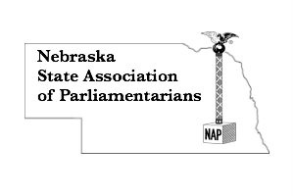
REGISTRATION FORM
For NSAP Members
May 13, 2022 4:00 - 5:00 p.m. Annual Meeting 5:30 p.m. Awards Banquet
May 14, 2022 8:00 a.m. until 3:45 p.m.
Best Western Plus – 2201 Wildcat Circle – Lincoln, Nebraska 68521
Topics: “How to Turn Three Hours into 45 minutes,” “What Voting Procedure is Best for Your Organization?,” and “Let’s See Your Minutes!”
Updated educational resources available for purchase!

Name__________________________________________________________
Email address ________________ Cell Phone number ___________________
Address, City, State, Zip Code _______________________________________
_______________________________________________________________
Registration includes:
All workshops by credentialed presenters, handouts, meeting room, banquet, lunch, and snacks. Complimentary water station. Coffee provided Saturday.
Special dietary needs: _________________________________________________
- Early Bird Registration……………………….……..$100.00 by May 1, 2022
- Regular Registration………………………….………$130.00 after May 1, 2022
Send completed form with check (payable to NSAP) to:
Lynna Gene Cook, 7251 Norris Lane, Lincoln, NE 68516
Participants responsible for own lodging:
Best Western Plus - 2201 Wildcat Circle – Lincoln, Nebraska 68521
Call the front desk for a reservation by April 13, 2022: 402.438.0088
Mention Nebraska State Association of Parliamentarians
Single room rate $109.99 plus tax

