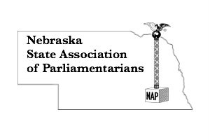
REGISTRATION FORM
For NSAP Members
May 28, 2021 2:45 p.m. to 5:00 p.m. Annual Meeting and Minutes Workshop
May 28, 2021 5:30 p.m. Awards Dinner and Installation of Officers
May 29, 2021 9:00 a.m. to 3:00 p.m.
Standing Rules and Policies and Procedures Workshop
Fellowship Community Church - 86th and Holdrege, Lincoln

Name__________________________________________________________
Email address ________________ Cell Phone number ___________________
Address, City, State, Zip Code _______________________________________
_______________________________________________________________
Registration includes:
All workshops by credentialed presenters, handouts,
lunch, snacks, and beverages
Special dietary needs: _________________________________________________
- Early Bird Registration……………………….……..$70.00 by May 15
- Regular Registration………………………….………$90.00 after May 15
- 5:30 p.m. Awards Dinner including Installation of Officers….$30.00 by May 15
Send completed form with check (payable to NSAP) to:
Lynna Gene Cook, 7251 Norris Lane, Lincoln, NE 68516
Drawing will be held and one lucky participant will receive a refund of the
2021 registration fee.
Participants responsible for own lodging.
Staybridge Suites, 84th and Holdrege, Lincoln, NE 402-484-6000
Comfort Suites Lincoln East – 331 North Cotner Blvd. 402-817-2456

