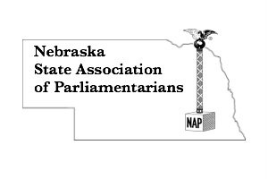REGISTRATION FORM
Smooth-Running Meetings, Voting, and Minutes Workshop
Public Invited to Attend!!!
May 14, 2022 8:00 a.m. until 3:45 p.m.
Best Western Plus – 2201 Wildcat Circle – Lincoln, Nebraska 68521
Name__________________________________________________________
Email address ________________ Cell Phone number ___________________
Address, City, State, Zip Code _______________________________________
_______________________________________________________________
Registration includes:
All workshops by credentialed presenters, handouts, meeting room, lunch,
and snacks. Complimentary water station and coffee.
Special dietary needs: _________________________________________________
>Early Bird Registration………………..$100.00 by May 1, 2022
>Student Early Bird Registration…...$ 50.00 by May 1, 2022
(middle school and high school students)

>Regular Registration……………..………$130.00 after May 1, 2022
>Student Regular Registration………..$ 60.00 after May 1, 2022
Send completed form with check (payable to NSAP) to:
Lynna Gene Cook, 7251 Norris Lane, Lincoln, NE 68516
Participants responsible for own lodging:
Best Western Plus - 2201 Wildcat Circle – Lincoln, Nebraska 68521
Call the front desk for a reservation by April 13, 2022: 402.438.0088
Mention Nebraska State Association of Parliamentarians
Single room rate $109.99 plus tax

