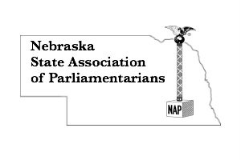
REGISTRATION FORM
For NSAP Members
May 15, 2021 Annual Meeting
Standing Rules and Policies and Procedures Workshop
Name__________________________________________________________
Email address ________________ Cell Phone number ___________________
Address, City, State, Zip Code _______________________________________
_______________________________________________________________
Registration includes:
All workshops by credentialed presenters and handouts.
___________________________________________________________________
- Early Bird Registration……………………….……..$50.00 by May 1
- Regular Registration………………………….………$65.00 after May 5
Send completed form with check (payable to NSAP) to:
Lynna Gene Cook, 7251 Norris Lane, Lincoln, NE 68516

